|  |  |  |  |
| --- | --- | --- | --- |
| Battery charging from 2.85 to 7.54 volt  ( Note:- add -0.02Amps to current readding ) | | | |
| 2022-06-09 05:40:28 UTC | 808 | -0.11 | 7.3 |
|  |  |  |  |
| 2022-06-09 05:42:08 UTC | 809 | -0.1 | 7.38 |
| 2022-06-09 05:42:58 UTC | 810 | -0.09 | 7.38 |
| 2022-06-09 05:44:39 UTC | 811 | -0.08 | 7.42 |
| 2022-06-09 05:49:40 UTC | 812 | -0.07 | 7.42 |
| 2022-06-09 05:50:32 UTC | 813 | -0.07 | 7.47 |
| 2022-06-09 05:51:24 UTC | 814 | -0.07 | 7.47 |
| 2022-06-09 05:53:53 UTC | 815 | -0.06 | 7.48 |
| 2022-06-09 05:54:42 UTC | 816 | -0.06 | 7.47 |
| 2022-06-09 05:57:13 UTC | 817 | -0.06 | 7.48 |
| 2022-06-09 05:58:03 UTC | 818 | -0.06 | 7.5 |
| 2022-06-09 05:58:53 UTC | 819 | -0.05 | 7.48 |
| 2022-06-09 05:59:44 UTC | 820 | -0.05 | 7.5 |
| 2022-06-09 06:00:34 UTC | 821 | -0.05 | 7.5 |
| 2022-06-09 06:01:24 UTC | 822 | -0.05 | 7.53 |
| 2022-06-09 06:02:15 UTC | 823 | -0.05 | 7.5 |
| 2022-06-09 06:03:05 UTC | 824 | -0.05 | 7.5 |
| 2022-06-09 06:03:55 UTC | 825 | -0.05 | 7.53 |
| 2022-06-09 06:04:45 UTC | 826 | -0.05 | 7.5 |
| 2022-06-09 06:05:36 UTC | 827 | -0.05 | 7.5 |
| 2022-06-09 06:06:26 UTC | 828 | -0.05 | 7.5 |
| 2022-06-09 06:07:16 UTC | 829 | -0.04 | 7.51 |
| 2022-06-09 06:08:06 UTC | 830 | -0.05 | 7.51 |
| 2022-06-09 06:08:57 UTC | 831 | -0.04 | 7.51 |
| 2022-06-09 06:09:47 UTC | 832 | -0.04 | 7.53 |
| 2022-06-09 06:10:37 UTC | 833 | -0.04 | 7.53 |
| 2022-06-09 06:11:27 UTC | 834 | -0.04 | 7.53 |
| 2022-06-09 06:12:18 UTC | 835 | -0.04 | 7.51 |
| 2022-06-09 06:13:08 UTC | 836 | -0.04 | 7.51 |
| 2022-06-09 06:13:58 UTC | 837 | -0.04 | 7.51 |
| 2022-06-09 06:14:49 UTC | 838 | -0.04 | 7.54 |
| 2022-06-09 06:15:39 UTC | 839 | -0.04 | 7.54 |
| 2022-06-09 06:16:29 UTC | 840 | -0.04 | 7.51 |
| 2022-06-09 06:17:19 UTC | 841 | -0.04 | 7.56 |
| 2022-06-09 06:18:10 UTC | 842 | -0.04 | 7.53 |
| 2022-06-09 06:19:00 UTC | 843 | -0.04 | 7.56 |
| 2022-06-09 06:19:50 UTC | 844 | -0.04 | 7.53 |
| 2022-06-09 06:20:41 UTC | 845 | -0.04 | 7.53 |
| 2022-06-09 06:21:31 UTC | 846 | -0.03 | 7.54 |
| 2022-06-09 06:22:21 UTC | 847 | -0.03 | 7.54 |
| 2022-06-09 06:23:11 UTC | 848 | -0.03 | 7.54 |
| 2022-06-09 06:24:02 UTC | 849 | -0.03 | 7.51 |
| 2022-06-09 06:24:52 UTC | 850 | -0.03 | 7.53 |
| 2022-06-09 06:25:42 UTC | 851 | -0.03 | 7.56 |
| 2022-06-09 06:26:32 UTC | 852 | -0.03 | 7.56 |
| 2022-06-09 06:27:23 UTC | 853 | -0.03 | 7.54 |
| 2022-06-09 06:28:13 UTC | 854 | -0.03 | 7.54 |
| 2022-06-09 06:29:03 UTC | 855 | -0.03 | 7.56 |
| 2022-06-09 06:29:53 UTC | 856 | -0.03 | 7.62 |
| 2022-06-09 06:30:44 UTC | 857 | -0.03 | 7.54 |
| 2022-06-09 06:31:34 UTC | 858 | -0.03 | 7.54 |
| 2022-06-09 06:32:25 UTC | 859 | -0.03 | 7.54 |
| 2022-06-09 06:34:06 UTC | 860 | -0.03 | 7.56 |
| 2022-06-09 06:34:56 UTC | 861 | -0.03 | 7.54 |
| 2022-06-09 06:36:37 UTC | 862 | -0.03 | 7.56 |
| 2022-06-09 06:39:57 UTC | 863 | -0.03 | 7.54 |
| 2022-06-09 06:40:47 UTC | 864 | -0.03 | 7.54 |
| 2022-06-09 06:41:40 UTC | 865 | -0.02 | 7.56 |
| 2022-06-09 06:42:29 UTC | 866 | -0.03 | 7.53 |
| 2022-06-09 06:43:18 UTC | 867 | -0.03 | 7.56 |
| 2022-06-09 06:44:58 UTC | 868 | -0.03 | 7.57 |
| 2022-06-09 06:45:50 UTC | 869 | -0.03 | 7.59 |
| 2022-06-09 06:46:39 UTC | 870 | -0.02 | 7.57 |
| 2022-06-09 06:47:29 UTC | 871 | -0.03 | 7.57 |
| 2022-06-09 06:48:20 UTC | 872 | -0.03 | 7.56 |
| 2022-06-09 06:49:12 UTC | 873 | -0.02 | 7.57 |
| 2022-06-09 06:50:00 UTC | 874 | -0.02 | 7.56 |
| 2022-06-09 06:50:53 UTC | 875 | -0.02 | 7.54 |
| 2022-06-09 06:52:32 UTC | 876 | -0.02 | 7.54 |
| 2022-06-09 06:57:38 UTC | 877 | -0.02 | 7.51 |
| 2022-06-09 06:58:27 UTC | 878 | -0.02 | 7.57 |
| 2022-06-09 06:59:16 UTC | 879 | -0.02 | 7.57 |
| 2022-06-09 07:00:58 UTC | 880 | -0.02 | 7.57 |
| 2022-06-09 07:02:35 UTC | 881 | -0.02 | 7.59 |
| 2022-06-09 07:03:24 UTC | 882 | -0.02 | 7.57 |
| 2022-06-09 07:05:06 UTC | 883 | -0.02 | 7.57 |
| 2022-06-09 07:05:55 UTC | 884 | -0.02 | 7.57 |
| 2022-06-09 07:06:46 UTC | 885 | -0.02 | 7.57 |
| 2022-06-09 07:08:27 UTC | 886 | -0.02 | 7.61 |
| 2022-06-09 07:10:07 UTC | 887 | -0.02 | 7.62 |
| 2022-06-09 07:10:57 UTC | 888 | -0.02 | 7.57 |
| 2022-06-09 07:11:47 UTC | 889 | -0.02 | 7.61 |
| 2022-06-09 07:12:37 UTC | 890 | -0.02 | 7.57 |
| 2022-06-09 07:16:02 UTC | 891 | -0.02 | 7.59 |
| 2022-06-09 07:16:49 UTC | 892 | -0.02 | 7.61 |
| 2022-06-09 07:19:20 UTC | 893 | -0.02 | 7.57 |
| 2022-06-09 07:20:10 UTC | 894 | -0.02 | 7.59 |
| 2022-06-09 07:21:01 UTC | 895 | -0.02 | 7.61 |
| 2022-06-09 07:21:52 UTC | 896 | -0.02 | 7.57 |

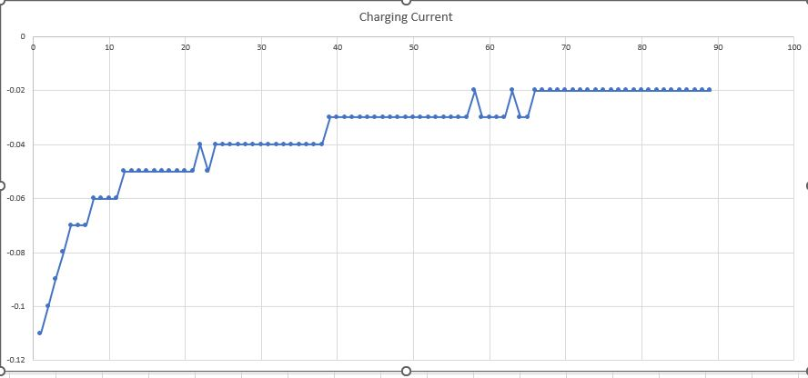

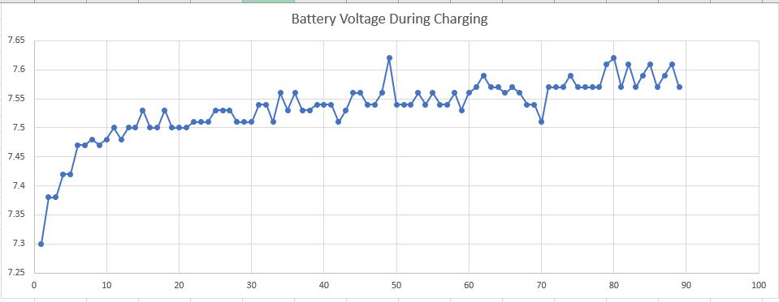

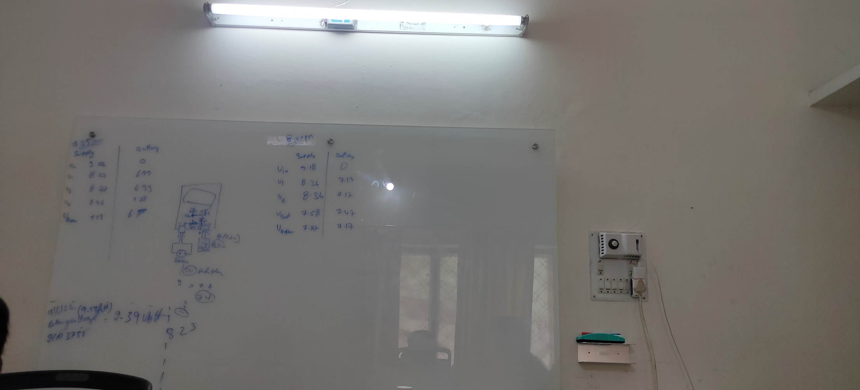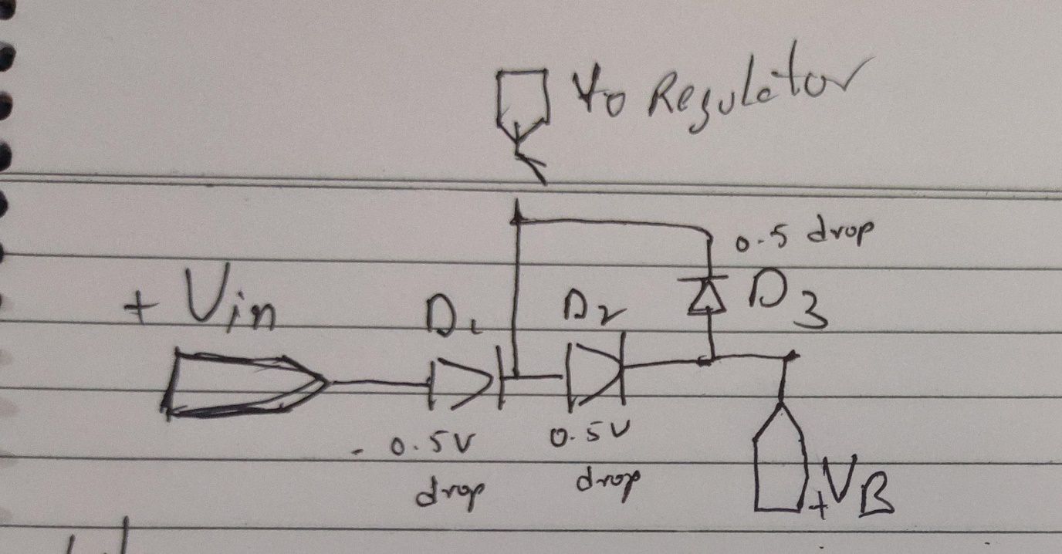

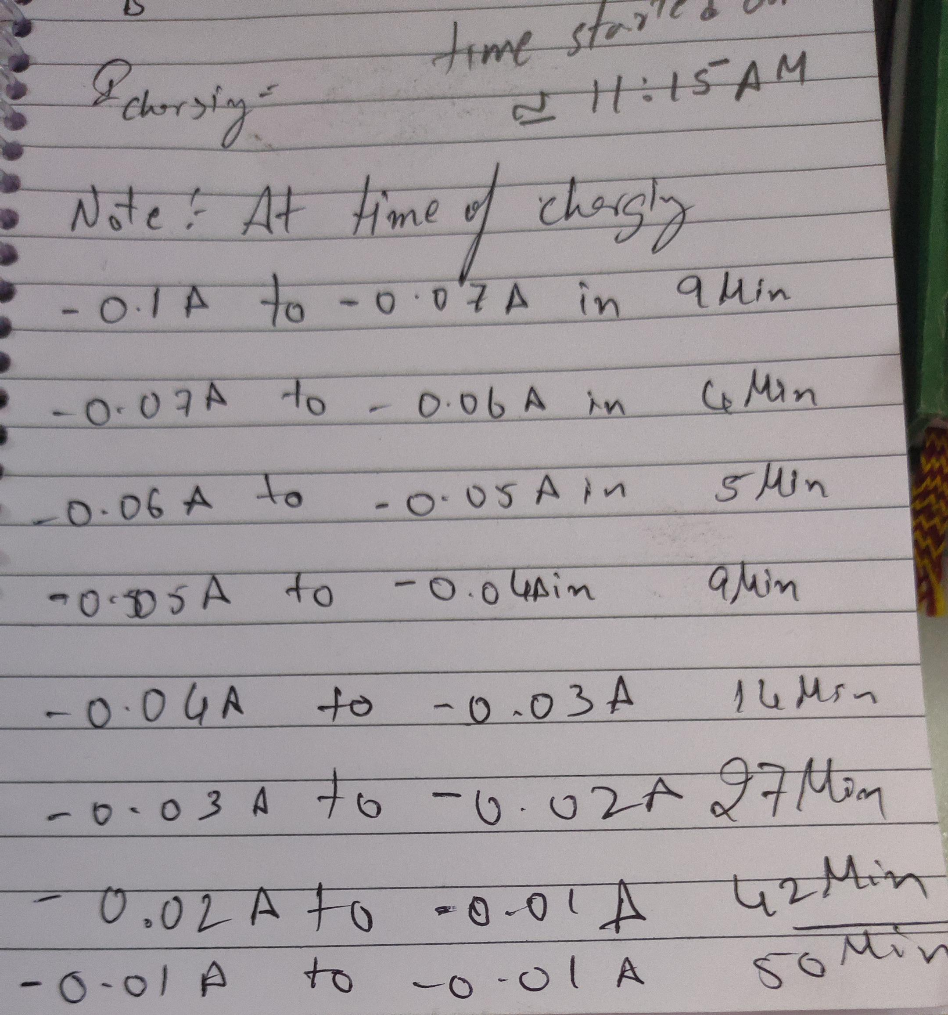

Note:-

The battery is charged from 2.85 Volt to 7.54 Volt. Kept Battery in charging for a 160 Min

.After the 160Min it still draws 0.01Amps of current from the adaptor.

|  |  |  |  |
| --- | --- | --- | --- |
| created_at | entry_id | Voltage | Current |
| 2022-06-09 07:22:02 UTC | 897 | 7.57 | 0.05 |
|  | 898 | 7.57 | 0.05 |
|  | 899 | 7.57 | 0.05 |
|  | 900 | 7.57 | 0.05 |
|  | 901 | 7.57 | 0.05 |
|  | 902 | 7.57 | 0.05 |
|  | 903 | 7.57 | 0.05 |
|  | 904 | 7.57 | 0.05 |
|  | 905 | 7.57 | 0.05 |
|  | 906 | 7.57 | 0.05 |
|  | 907 | 7.57 | 0.05 |
|  | 908 | 7.57 | 0.05 |
|  | 909 | 7.57 | 0.05 |
|  | 910 | 7.57 | 0.05 |
|  | 911 | 7.57 | 0.05 |
|  | 912 | 7.57 | 0.05 |
|  | 913 | 7.57 | 0.05 |
|  | 914 | 7.5 | 0.05 |
|  | 915 | 7.5 | 0.05 |
|  | 916 | 7.5 | 0.05 |
|  | 917 | 7.5 | 0.05 |
|  | 918 | 7.5 | 0.05 |
|  | 919 | 7.5 | 0.05 |
|  | 920 | 7.5 | 0.05 |
|  | 921 | 7.5 | 0.05 |
|  | 922 | 7.5 | 0.05 |
|  | 923 | 7.5 | 0.05 |
|  | 924 | 7.5 | 0.05 |
|  | 925 | 7.5 | 0.05 |
|  | 926 | 7.5 | 0.05 |
|  | 927 | 7.5 | 0.05 |
|  | 928 | 7.5 | 0.05 |
|  | 929 | 7.5 | 0.05 |
|  | 930 | 7.5 | 0.05 |
|  | 931 | 7.5 | 0.05 |
|  | 932 | 7.5 | 0.05 |
|  | 933 | 7.5 | 0.05 |
|  | 934 | 7.5 | 0.05 |
|  | 935 | 7.5 | 0.05 |
|  | 936 | 7.5 | 0.05 |
|  | 937 | 7.5 | 0.05 |
|  | 938 | 7.5 | 0.05 |
|  | 939 | 7.5 | 0.05 |
|  | 940 | 7.5 | 0.05 |
|  | 941 | 7.5 | 0.05 |
|  | 942 | 7.5 | 0.05 |
|  | 943 | 7.5 | 0.05 |
|  | 944 | 7.5 | 0.05 |
|  | 945 | 7.4 | 0.05 |
|  | 946 | 7.4 | 0.05 |
|  | 947 | 7.4 | 0.05 |
|  | 948 | 7.4 | 0.05 |
|  | 949 | 7.4 | 0.05 |
|  | 950 | 7.4 | 0.05 |
|  | 951 | 7.4 | 0.05 |
|  | 952 | 7.4 | 0.05 |
|  | 953 | 7.4 | 0.05 |
|  | 954 | 7.4 | 0.05 |
|  | 955 | 7.4 | 0.05 |
|  | 956 | 7.4 | 0.05 |
|  | 957 | 7.4 | 0.05 |
|  | 958 | 7.4 | 0.05 |
|  | 959 | 7.4 | 0.05 |
|  | 960 | 7.4 | 0.05 |
|  | 961 | 7.4 | 0.05 |
|  | 962 | 7.4 | 0.05 |
|  | 963 | 7.4 | 0.05 |
|  | 964 | 7.4 | 0.05 |
|  | 965 | 7.4 | 0.05 |
|  | 966 | 7.4 | 0.05 |
|  | 967 | 7.4 | 0.05 |
|  | 968 | 7.4 | 0.05 |
|  | 969 | 7.4 | 0.05 |
|  | 970 | 7.4 | 0.05 |
|  | 971 | 7.4 | 0.05 |
|  | 972 | 7.4 | 0.05 |
|  | 973 | 7.4 | 0.05 |
|  | 974 | 7.4 | 0.05 |
|  | 975 | 7.4 | 0.05 |
|  | 976 | 7.4 | 0.05 |
|  | 977 | 7.4 | 0.05 |
|  | 978 | 7.4 | 0.05 |
|  | 979 | 7.4 | 0.05 |
|  | 980 | 7.4 | 0.05 |
|  | 981 | 7.4 | 0.05 |
|  | 982 | 7.4 | 0.05 |
|  | 983 | 7.4 | 0.05 |
|  | 984 | 7.4 | 0.05 |
|  | 985 | 7.4 | 0.05 |
|  | 986 | 7.4 | 0.05 |
|  | 987 | 7.4 | 0.05 |
|  | 988 | 7.4 | 0.05 |
|  | 989 | 7.4 | 0.05 |
|  | 990 | 7.4 | 0.05 |
|  | 991 | 7.4 | 0.05 |
|  | 992 | 7.4 | 0.05 |
|  | 993 | 7.4 | 0.05 |
|  | 994 | 7.4 | 0.05 |
|  | 995 | 7.4 | 0.05 |
|  | 996 | 7.4 | 0.05 |
|  | 997 | 7.4 | 0.05 |
|  | 998 | 7.3 | 0.05 |
|  | 999 | 7.3 | 0.05 |
|  | 1000 | 7.3 | 0.05 |
|  | 1001 | 7.3 | 0.05 |
|  | 1002 | 7.3 | 0.05 |
|  | 1003 | 7.3 | 0.05 |
|  | 1004 | 7.3 | 0.05 |
|  | 1005 | 7.3 | 0.05 |
|  | 1006 | 7.3 | 0.05 |
|  | 1007 | 7.3 | 0.05 |
|  | 1008 | 7.3 | 0.05 |
|  | 1009 | 7.3 | 0.05 |
|  | 1010 | 7.3 | 0.05 |
|  | 1011 | 7.3 | 0.05 |
|  | 1012 | 7.3 | 0.05 |
|  | 1013 | 7.3 | 0.05 |
|  | 1014 | 7.3 | 0.05 |
|  | 1015 | 7.3 | 0.05 |
|  | 1016 | 7.3 | 0.05 |
| 2022-06-09 09:23:20 UTC | 1018 | 7.21 | 0.05 |
| 2022-06-09 09:24:10 UTC | 1019 | 7.22 | 0.05 |
| 2022-06-09 09:25:00 UTC | 1020 | 7.24 | 0.05 |
| 2022-06-09 09:25:50 UTC | 1021 | 7.24 | 0.05 |
| 2022-06-09 09:26:41 UTC | 1022 | 7.24 | 0.05 |
| 2022-06-09 09:27:31 UTC | 1023 | 7.25 | 0.05 |
| 2022-06-09 09:28:21 UTC | 1024 | 7.21 | 0.05 |
| 2022-06-09 09:29:12 UTC | 1025 | 7.22 | 0.05 |
| 2022-06-09 09:30:02 UTC | 1026 | 7.22 | 0.05 |
| 2022-06-09 09:30:53 UTC | 1027 | 7.24 | 0.05 |
| 2022-06-09 09:31:42 UTC | 1028 | 7.24 | 0.05 |
| 2022-06-09 09:32:33 UTC | 1029 | 7.24 | 0.05 |
| 2022-06-09 09:33:23 UTC | 1030 | 7.21 | 0.05 |
| 2022-06-09 09:34:13 UTC | 1031 | 7.22 | 0.05 |
| 2022-06-09 09:35:04 UTC | 1032 | 7.19 | 0.05 |
| 2022-06-09 09:35:54 UTC | 1033 | 7.19 | 0.05 |
| 2022-06-09 09:36:44 UTC | 1034 | 7.19 | 0.05 |
| 2022-06-09 09:37:34 UTC | 1035 | 7.18 | 0.05 |
| 2022-06-09 09:38:25 UTC | 1036 | 7.19 | 0.05 |
| 2022-06-09 09:39:15 UTC | 1037 | 7.19 | 0.05 |
| 2022-06-09 09:40:05 UTC | 1038 | 7.18 | 0.05 |
| 2022-06-09 09:40:55 UTC | 1039 | 7.16 | 0.05 |
| 2022-06-09 09:41:46 UTC | 1040 | 7.16 | 0.05 |
| 2022-06-09 09:42:36 UTC | 1041 | 7.16 | 0.05 |
| 2022-06-09 09:43:26 UTC | 1042 | 7.13 | 0.05 |
| 2022-06-09 09:44:17 UTC | 1043 | 7.14 | 0.05 |
| 2022-06-09 09:45:07 UTC | 1044 | 7.14 | 0.05 |
| 2022-06-09 09:45:57 UTC | 1045 | 7.13 | 0.05 |
| 2022-06-09 09:46:47 UTC | 1046 | 7.14 | 0.05 |
| 2022-06-09 09:47:38 UTC | 1047 | 7.13 | 0.05 |
| 2022-06-09 09:48:28 UTC | 1048 | 7.14 | 0.05 |
| 2022-06-09 09:49:18 UTC | 1049 | 7.13 | 0.05 |
| 2022-06-09 09:50:08 UTC | 1050 | 7.13 | 0.05 |
| 2022-06-09 09:50:59 UTC | 1051 | 7.13 | 0.05 |
| 2022-06-09 09:51:49 UTC | 1052 | 7.11 | 0.05 |
| 2022-06-09 09:52:39 UTC | 1053 | 7.16 | 0.05 |
| 2022-06-09 09:53:30 UTC | 1054 | 7.11 | 0.05 |
| 2022-06-09 09:54:20 UTC | 1055 | 7.11 | 0.05 |
| 2022-06-09 09:55:10 UTC | 1056 | 7.11 | 0.05 |
| 2022-06-09 09:56:00 UTC | 1057 | 7.11 | 0.05 |
| 2022-06-09 09:56:51 UTC | 1058 | 7.08 | 0.05 |
| 2022-06-09 09:57:41 UTC | 1059 | 7.1 | 0.05 |
| 2022-06-09 09:58:31 UTC | 1060 | 7.1 | 0.05 |
| 2022-06-09 09:59:21 UTC | 1061 | 7.07 | 0.05 |
| 2022-06-09 10:00:12 UTC | 1062 | 7.08 | 0.05 |
| 2022-06-09 10:01:02 UTC | 1063 | 7.08 | 0.05 |
| 2022-06-09 10:01:52 UTC | 1064 | 7.07 | 0.05 |
| 2022-06-09 10:02:43 UTC | 1065 | 7.07 | 0.05 |
| 2022-06-09 10:03:33 UTC | 1066 | 7.05 | 0.05 |
| 2022-06-09 10:04:23 UTC | 1067 | 7.04 | 0.05 |
| 2022-06-09 10:05:13 UTC | 1068 | 7.07 | 0.05 |
| 2022-06-09 10:06:04 UTC | 1069 | 7.04 | 0.05 |
| 2022-06-09 10:06:54 UTC | 1070 | 7.04 | 0.05 |
| 2022-06-09 10:07:44 UTC | 1071 | 7.04 | 0.05 |
| 2022-06-09 10:08:34 UTC | 1072 | 7.02 | 0.05 |
| 2022-06-09 10:09:25 UTC | 1073 | 7.04 | 0.05 |
| 2022-06-09 10:10:15 UTC | 1074 | 7.01 | 0.05 |
| 2022-06-09 10:11:05 UTC | 1075 | 7.02 | 0.05 |
| 2022-06-09 10:11:55 UTC | 1076 | 6.99 | 0.06 |
| 2022-06-09 10:12:46 UTC | 1077 | 6.78 | 0.05 |
| 2022-06-09 10:13:36 UTC | 1078 | 6.98 | 0.05 |
| 2022-06-09 10:14:26 UTC | 1079 | 6.98 | 0.05 |
| 2022-06-09 10:15:17 UTC | 1080 | 6.98 | 0.05 |
| 2022-06-09 10:16:07 UTC | 1081 | 6.96 | 0.05 |
| 2022-06-09 10:16:59 UTC | 1082 | 6.94 | 0.05 |
| 2022-06-09 10:17:47 UTC | 1083 | 6.93 | 0.05 |
| 2022-06-09 10:18:38 UTC | 1084 | 6.94 | 0.05 |
| 2022-06-09 10:19:28 UTC | 1085 | 6.93 | 0.05 |
| 2022-06-09 10:20:18 UTC | 1086 | 6.91 | 0.05 |
| 2022-06-09 10:21:08 UTC | 1087 | 6.9 | 0.05 |
| 2022-06-09 10:21:59 UTC | 1088 | 6.91 | 0.05 |
| 2022-06-09 10:22:49 UTC | 1089 | 6.91 | 0.05 |
| 2022-06-09 10:23:39 UTC | 1090 | 6.87 | 0.06 |
| 2022-06-09 10:24:30 UTC | 1091 | 6.88 | 0.05 |
| 2022-06-09 10:25:20 UTC | 1092 | 6.85 | 0.05 |
| 2022-06-09 10:27:22 UTC | 1093 | 6.84 | 0.05 |
| 2022-06-09 10:28:12 UTC | 1094 | 6.82 | 0.05 |
| 2022-06-09 10:29:03 UTC | 1095 | 6.81 | 0.05 |
| 2022-06-09 10:29:53 UTC | 1096 | 6.79 | 0.05 |
| 2022-06-09 10:30:43 UTC | 1097 | 6.78 | 0.05 |
| 2022-06-09 10:31:33 UTC | 1098 | 6.75 | 0.05 |
| 2022-06-09 10:32:24 UTC | 1099 | 6.73 | 0.05 |
| 2022-06-09 10:33:14 UTC | 1100 | 6.7 | 0.05 |
| 2022-06-09 10:34:04 UTC | 1101 | 6.64 | 0.05 |
| 2022-06-09 10:34:55 UTC | 1102 | 6.62 | 0.05 |
| 2022-06-09 10:35:45 UTC | 1103 | 6.55 | 0.05 |
| 2022-06-09 10:36:35 UTC | 1104 | 6.47 | 0.05 |
| 2022-06-09 10:37:25 UTC | 1105 | 6.35 | 0.06 |
| 2022-06-09 10:38:16 UTC | 1106 | 6.22 | 0.05 |
| 2022-06-09 10:39:06 UTC | 1107 | 6.12 | 0.05 |
| 2022-06-09 10:39:56 UTC | 1108 | 2.37 | 0.01 |
| 2022-06-09 10:40:46 UTC | 1109 | 2.4 | 0.01 |
| 2022-06-09 10:41:37 UTC | 1110 | 2.38 | 0.01 |
| 2022-06-09 10:44:08 UTC | 1111 | 2.38 | 0.01 |
| 2022-06-09 10:44:58 UTC | 1112 | 2.38 | 0.01 |
| 2022-06-09 10:45:48 UTC | 1113 | 2.38 | 0.01 |
| 2022-06-09 10:46:38 UTC | 1114 | 2.4 | 0.01 |
| 2022-06-09 10:47:29 UTC | 1115 | 2.43 | 0.01 |
| 2022-06-09 10:48:19 UTC | 1116 | 2.4 | 0.01 |
| 2022-06-09 10:49:09 UTC | 1117 | 2.4 | 0.01 |

